**Computer Project**

**Name** : Mostafa Mohamed Awad Hassan Ibrahim

**Section** : 42

Group : 7

**B.N** : 931

**Topic**  : Computer Engineering Role in COVID-19 Pandemic

**Gethub Link** : https://github.com/MostafaSarar/html-project-new-repository

**Application**

The topic is about the Corona virus and include

Introduction to the corona virus -1

Reasons for the spread of the Corona virus -2

Statistics for the spread of the Corona virus -3

4- Ways to prevent the virus

The Rolling of Computer Engineering -5

The reason for choosing the topic is because the Corona virus is a great danger in the world and should be dealt with carefully

**Screen shots :**

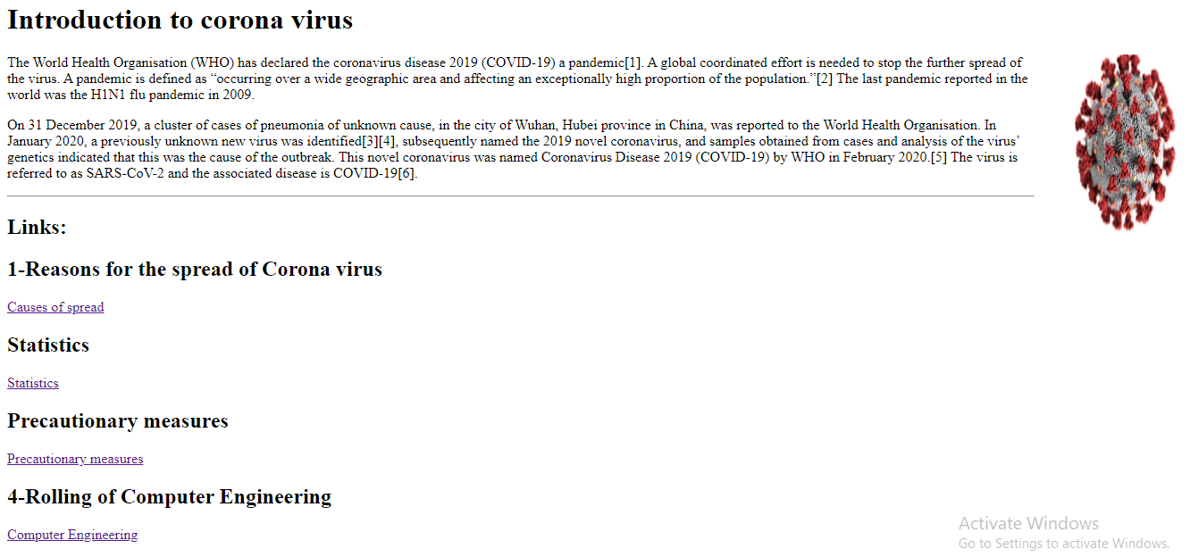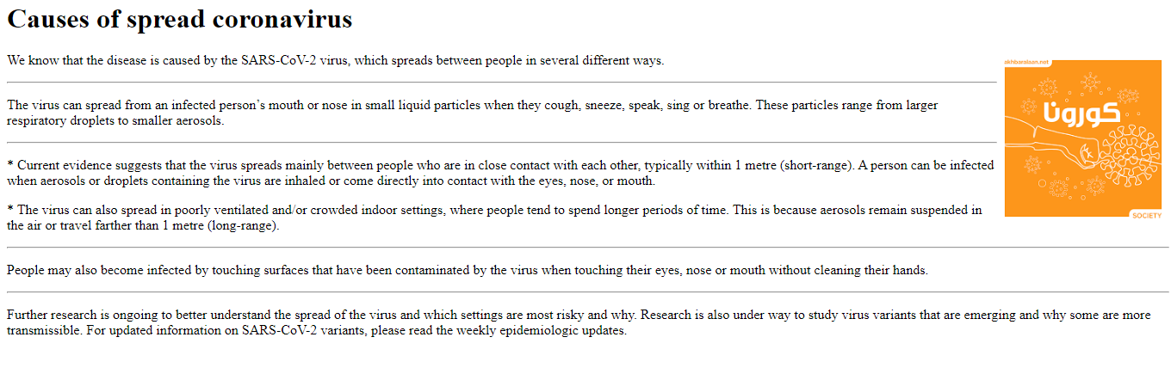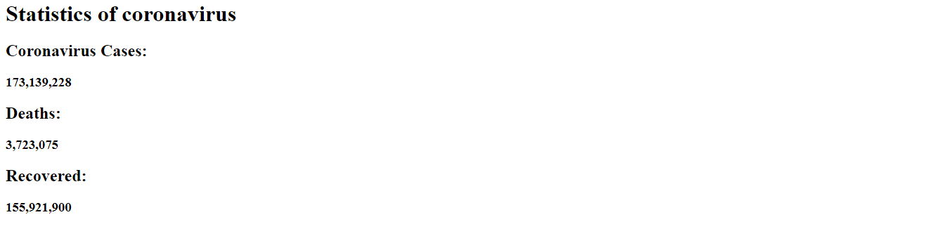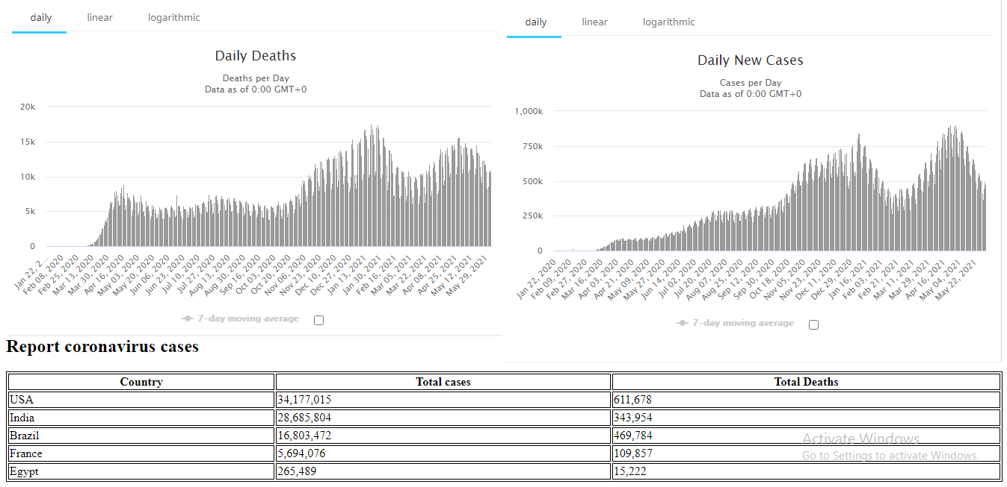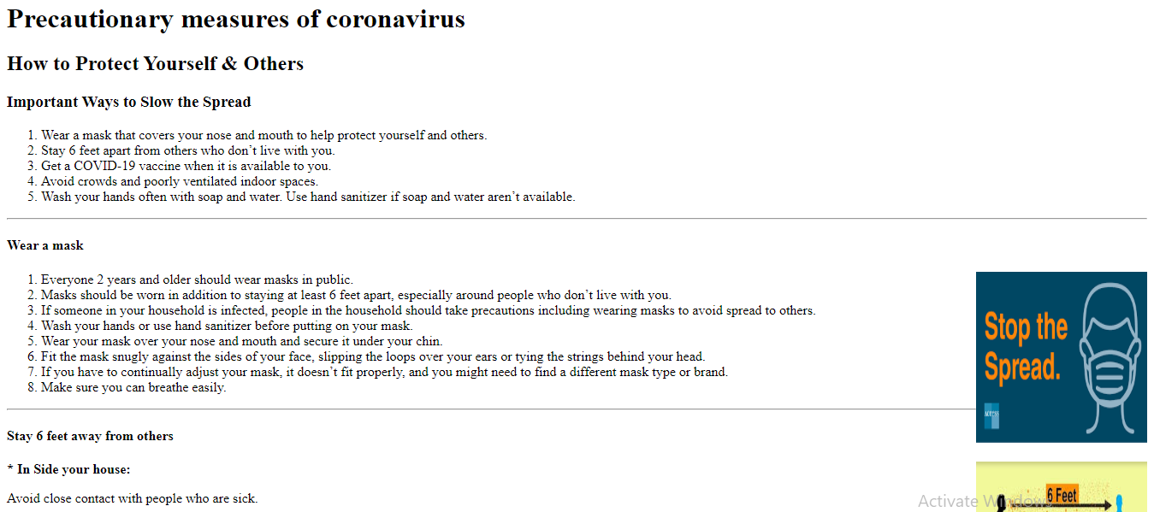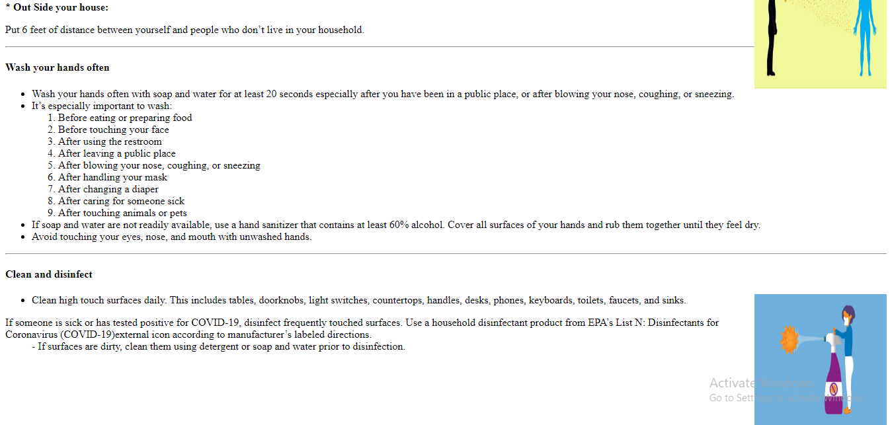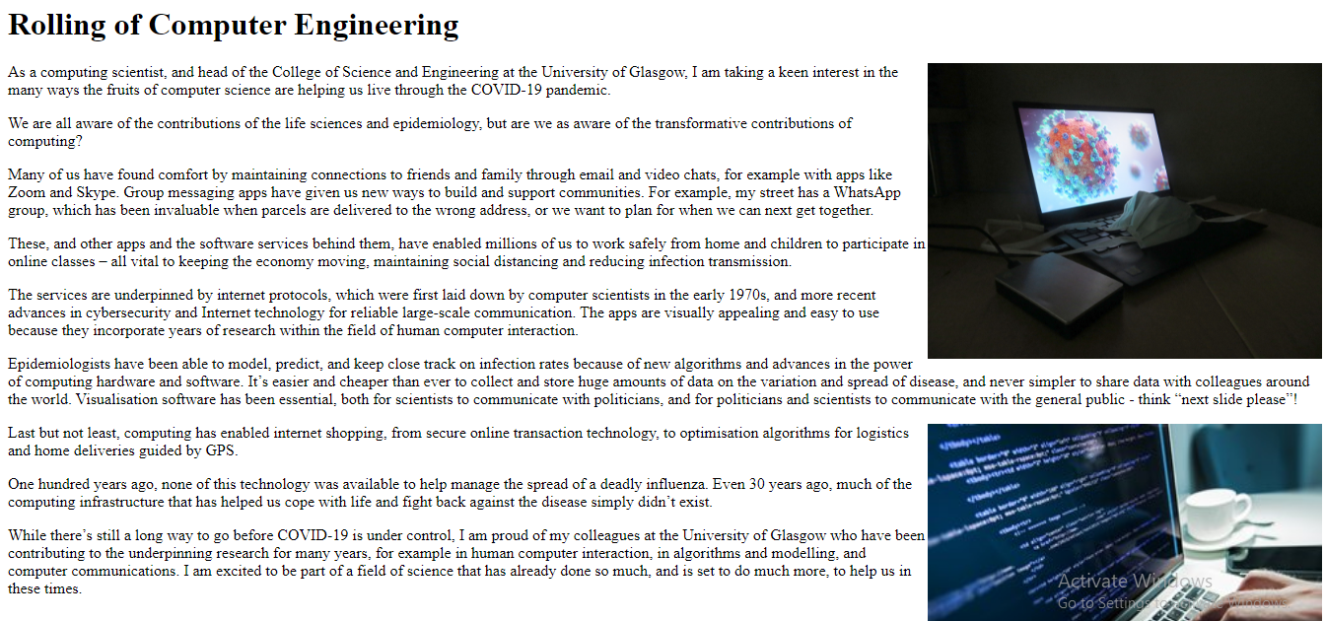

**Source code :**

